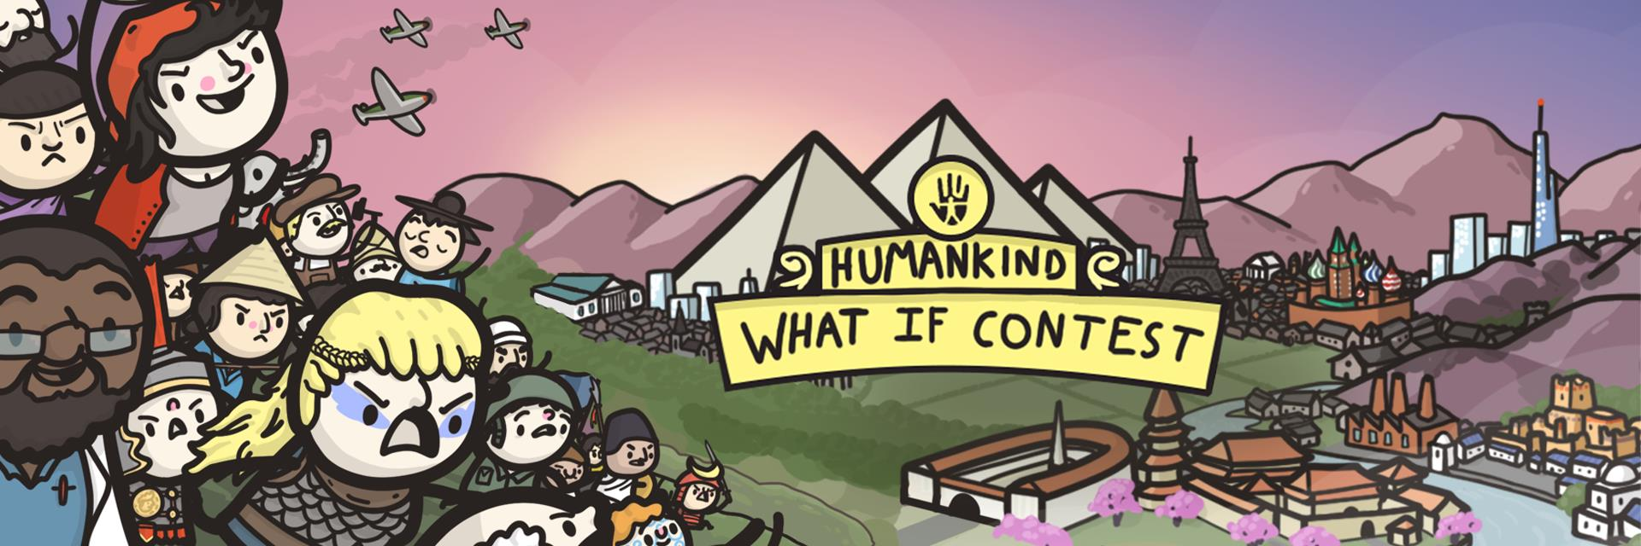

AMPLITUDE IS LAUNCHING THE OFFICIAL HUMANKIND “WHAT IF” CONTEST

Create your own alternate history using our custom-built “What If” meme generator. Participate in themed contests each week to win prizes!

Paris, July 16th – Do you love history? Memes? Wasting time on the internet? Well, we have got some exciting news for you. Today we’re launching the official Humankind “What If” website, complete with a meme generator that will allow you to create any version of history that you can imagine.
THE WHAT IF CONTEST
Humankind the game, our game that is, is a historical strategy title that will allow players to ask themselves the question “What If?” – What if the Khmer had fought at the Battle of Hastings? What if the Ottoman empire had survived to the modern day? What if the game had not been delayed to 2021?
But, while we await the opportunity to change the course of history in gameplay, for now we’ll stick to doing so in images. Each and every week, for 10 weeks, we’ll be announcing a new contest theme, and asking you to come up with your best ideas for the chance to win prizes like free game keys, the ability to play Humankind before its release, and more!
Then, our weekly winners will face off in the community voting challenge, whose grand prize winner will get the entire SEGA catalog of PC Games on Steam, for free!

VISIT THE WEBSITE || WATCH THE TRAILER

DON’T FORGET TO SIGN UP FOR OPENDEV
While we’re here, we’d like to remind players as well that they can sign up now to be a part of our OpenDev program. Later this month, we’ll be granting access to a the first in a series of time-limited gameplay scenarios. Your feedback will help us refine the game!

SIGN UP FOR OPENDEV

We hope you enjoy!

- The Ampliteam
--
For more information about Humankind visit https://humankind.game, or follow us on Facebook, Twitter, & Instagram. Learn more about SEGA at https://sega.co.uk.

